

St Joseph’s Catholic Primary School

SEND Information Report 2026-2027


Our School Approach:

St Joseph’s Catholic Primary School, Bradford, is a fully inclusive mainstream primary school where every child is valued, supported and encouraged to reach their full potential.

We are committed to providing an inclusive and nurturing learning environment in which all pupils can thrive academically, socially, emotionally and personally, regardless of their background, abilities or individual needs.
We provide a broad, balanced and inclusive curriculum that enables every child to achieve their best. We have equally high expectations for all pupils, including those with Special Educational Needs and Disabilities (SEND), and strive to ensure that everyone has the opportunity to succeed and flourish.
Current Information:
St Joseph’s currently has 340 students on role (October 2026).
Year Group | Number of  children in Year  Group | Number on the SEND Register | Number of SEND who are CLA | Percentage of the Year Group | Number of children on Ranges 1-3 | Number of children on  Range 4/EHCP | Number of EHCP pending.
Nursery | 36 | 2 | 0 | 6 | 3 | 0 | 0
Reception | 44 | 4 | 0 | 9 | 4 | 0 | 1
Year 1 | 42 | 6 | 0 | 14 | 4 | 2 | 0
Year 2 | 42 | 6 | 0 | 14 | 4 | 2 | 1
Year 3 | 46 | 16 | 2 | 39 | 12 | 4 | 0
Year 4 | 41 | 10 | 0 | 24 | 8 | 2 | 0
Year 5 | 43 | 12 | 0 | 28 | 10 | 2 | 0
Year 6 | 46 | 8 | 0 | 17 | 6 | 2 | 0


Meet the SENDCO Team:
At St Joseph’s, we have two SENDCOs – Mrs Amy Fox and Miss Megan Firth. If you would like to contact them, please call the school on 01274 727970 or email amy.fox@sjbr.bcwcat.co.uk or megan.firsth@sjbr.bcwcat.co.uk

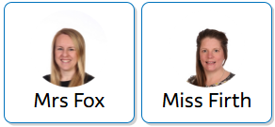
Mrs Fox and Miss Firth have both worked at St Joseph’s for over 12 years and hold the relevant qualifications. They both work in partnership with the Blessed Christopher Wharton Catholic Academy Trust – BCWCAT.

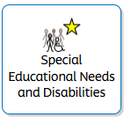
At St Joseph’s, we support children with a variety of differing special educational needs and disabilities. We are a highly inclusive school with a mission to Protect all of God’s gifts. SEND is categorised into the follow areas in the SEND Code of Practice 2014. At St Joseph’s we have a wide range of needs across the whole school.

ASD | SEMH | C&L | SLCN | Physical | HI | SpLD | ADHD | Medical | Other
16 | 24 | 4 | 32 | 1 | 0 | 1 | 0 | 1 | 1

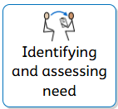
How do we identify children with Special Educational Needs and Difficulties?
We identify children with Special Educational Needs and Disabilities (SEND) in a variety of ways. Some children may have already been identified before joining St. Joseph’s, and we work closely with families and professionals to ensure appropriate support is in place.

If parents or carers raise concerns about their child’s needs, we will discuss these together, consider any necessary assessments and agree on appropriate next steps and support.

Similarly, if teachers notice that a child is making less progress than expected, they will discuss their concerns with parents or carers. Further observations and assessments may then be carried out to identify potential barriers to learning.

Teachers and SENDCos work together to identify areas of need, set SMART targets and implement tailored strategies and interventions through an Individual Education Plan (IEP).

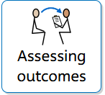
Assessing and reviewing pupils' progress towards outcomes.
We follow the graduated approach and the four-part cycle of assess, plan, do, review. (APDR)
The class or subject teacher will work with the SENDCOs to carry out a clear analysis of the pupil’s needs. This will draw on:
- The teacher’s assessment and experience of the pupil
- Their previous progress and attainment or behaviour
- Other teachers’ assessments, where relevant
- The individual’s development in comparison to their peers and national data
- The views and experience of parents
- The pupil’s own views
- Advice from external support services, if relevant
Assessments are reviewed regularly to ensure that each pupil’s needs are identified and appropriately supported. All staff working with the child are made aware of their individual needs through a one-page profile. Specific targets, support, teaching strategies and interventions are outlined in an Individual Education Plan (IEP).
IEPs are reviewed every half term to evaluate the effectiveness of the support provided and the progress made. These reviews are shared and discussed with parents and carers.
Targets are assessed as met, partially met or not met. Where a target has been achieved, new targets are set to build on progress. Partially met targets may be continued to allow further time for consolidation, while targets that have not been met are adapted, with alternative strategies or approaches introduced where necessary. This ensures that support remains responsive to each child’s individual needs and promotes continued progress.
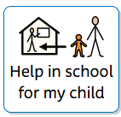
How could my child get help in school?
Children in school will get support that is specific to their individual needs. This will be provided by the class teacher and may also involve other staff in the school:

- Staff may visit the school from the Local Authority central services; such as the Autistic Spectrum Disorder (ASD)/Social. Communication, Interaction and Learning (SCIL), Behaviour Support Services, Learning Support Services or Visual Impairment Team, CAHMS, Physio and Paediatricians.
- The SENDCo may make a referral to the Speech and Language service who will visit to complete an assessment and then either make recommendations on strategies for the teacher to use or return to carry out a speech and language sessions in school addressing receptive and expressive language.
- Our School Nursing team is available to support your child via a referral process
- Children’s mental health and well-being is supported by the school’s Mental Health Champion, the CAS Lead (Creating Active Schools) and the Nurture Team. We have also commissioned an Art Therapist to work on recognising and regulating emotions.


How can I let the school know that I am concerned about my child’s progress in school?
If you have concerns about your child’s progress, you should speak to your child’s teacher initially. The concerns may need referring to the SENDCo if your child is not making progress. Regular meetings will be scheduled to monitor progression and impact and the outcomes shared with you on a half termly basis.
You can raise concerns during the IEP review and make any amendments to the IEP that you feel need to be made. If you continue to feel your child is not making enough progress, you should speak to the Headteacher or the SEND Governor.
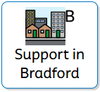
Are there any support services available to the parents of children with SEND?
Yes. There are many local and national organisations who can offer support and advice, including some charities and voluntary bodies.

Parents and carers seeking additional advice and support can access a range of services and organisations.

Bradford Parent Partnership offers information, advice and guidance to families of children with SEND.
- Telephone: 01274 481183
- Website: Parent Partnership Service

Catholic Care provides a range of support services for children and families.
- Website: www.catholic-care.org.uk

Our SENDCos are also available to help parents and carers identify appropriate specialist services, access further advice and make self-referrals to external agencies where needed.

  Barnard’s SENDIASS | 01274 513300
Bradford Early Advice Team | 01535 661275
Children’s Community Support Team | 01274 436684
  Child Development Service | 01274 365423
Bradford SEND Team | 01274 435750

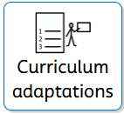
How do we teach children with SEND and adapt the curriculum and learning environment to support children with SEND?

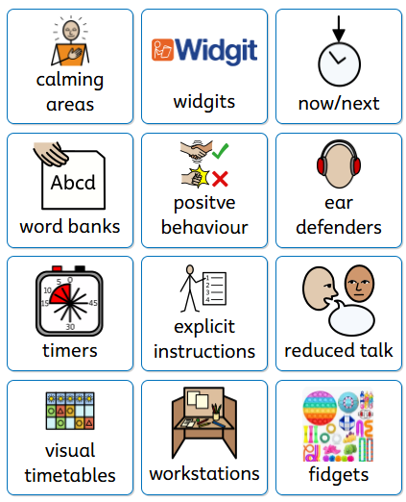
At St Joseph’s, we use a range of inclusive teaching strategies across all lessons to ensure that every child can access learning and participate fully in school life. Staff work collaboratively to create a supportive, accessible learning environment that meets the individual needs of all pupils.
Visuals are added to our digital ILP’s to ensure that all staff are aware of a child’s individual adaptations.
We also seek advice from outside agencies as and when the need arises.

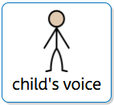
How do we consult children with Special Educational Needs and Difficulties and involve them in their Education?
At St Joseph’s, we value pupil voice and encourage all children to understand and discuss their individual learning targets with their class teacher. Children with SEND are actively involved in developing and reviewing their Individual Education Plans (IEPs).
They are encouraged to share their views about school, including what they enjoy, what they find challenging and how they feel they can best be supported.
Children with an Education, Health and Care Plan (EHCP) are also encouraged to contribute to their annual review, sharing their experiences, achievements, views and wishes to ensure their voices are heard and their needs remain at the centre of their support.
Pupils are given opportunities to:


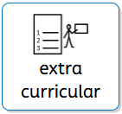
What extra-curricular activities are available to children with SEND?
Our extra-curricular activities and school visits are available for all our children – this includes Breakfast Club and After School club. School/Parent meetings are carried out beforehand if necessary to discuss any Risk Assessments or procedures that need to be in place to support the child.
- All children are encouraged to go on our trips.
- All children are encouraged to take part in Sports Day, school competitions, school assemblies and performances.
- No child is ever excluded from taking part in these activities because of their needs or disabilities.
Please read the school’s accessibility plan for further information about the steps we have taken to prevent disabled children from being treated less favourably than other children and the arrangements we have made to help children with SEND access our school. This is available on our school website.
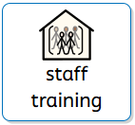
How does the school train staff and secure specialist expertise?
At St Joseph’s, training on how best to support pupils with SEND forms part of our ongoing professional development programme. Additional specialist training is provided for staff where needed, ensuring they have the knowledge and skills to meet the individual needs of pupils.
Our SENDCo works closely with a range of external agencies, including Speech and Language Therapy, SEND Support Services, CAMHS, School Health, Educational Psychology, the School Nurse, Child Development Centre, Hearing and Visual Impairment Services and parent support groups. The SENDCo also attends Bradford Local Authority and BCWCAT meetings to stay informed of local and national SEND developments.
Class teachers are expected to have a thorough understanding of the needs of pupils in their class and access additional training where appropriate. Teaching assistants also receive relevant training to ensure they are confident and well prepared to deliver targeted interventions to individuals or groups.
We recognise the importance of continuous professional development in ensuring all staff are equipped to provide high-quality teaching, support and care for children with SEND.
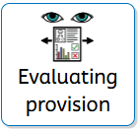
How do we evaluate the effectiveness of the provision for children with SEND?
Every half term IEPs are evaluated and updated. At this point the SENDCO looks at each target outcome and the effect the provision has had on progress. Pupil progress meetings happen every term, these also look at interventions put in place for individual children and how this has impacted upon progress.
Annual reviews are held for children with an EHCP, and provision and targets are reviewed and rewritten. Provision is also monitored by the SENDCO through lesson observations, planning scrutinies book looks, learning walks and reviewing assessment data.


What is the admission procedure for children with SEND?
At St Joseph’s, we welcome applications from all children, including those with Special Educational Needs and Disabilities (SEND), through our usual admissions process.
We encourage parents and carers to share as much information as possible about their child’s needs so that appropriate support can be planned before they start school. We also work closely with previous settings to ensure a smooth transition and effective sharing of information.

For children with an Education, Health and Care Plan (EHCP), the Local Authority may consult with us regarding a school place. We carefully consider the needs outlined in the EHCP and how we can best meet them. Where there are concerns about our ability to provide the required support or provision, we work with the Local Authority and families to explore appropriate options, in line with statutory guidance.
As a School of Sanctuary, St Joseph’s is committed to welcoming and including all children and families. Our priority is to ensure that every child has access to a safe, supportive learning environment where they can thrive and reach their full potential.

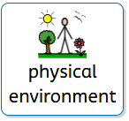
How do we monitor and improve the physical environment to increase the extent to which SEND pupils can use facilities and services?
At St Joseph’s, we regularly review our school environment and carry out risk assessments to ensure it is safe and accessible for all pupils, staff and families.
All new parents and carers are offered a tour of the school before their child starts. Families of children with SEND are encouraged to raise any accessibility concerns so that we can work together to identify appropriate adjustments and ensure their child’s needs are met.
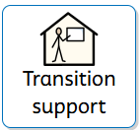
How do we support transition for pupils with SEND?
Nursery to Reception Transition
At St Joseph’s, we aim to make the transition into Reception as smooth and positive as possible. During the summer term, we invite parents and carers to New to Reception Evening where they can meet the class teacher and SENDCo and discuss any individual needs.
Children are offered taster sessions to familiarise themselves with their new classroom, staff and routines. Additional visits, small-group sessions and visual supports, such as social stories, are provided for children who may need extra support with their transition.
End of Year Transition
We carefully plan transitions between year groups to ensure children feel happy, confident and prepared for their new class.
During the summer term, all children take part in a transition session, which is held in line with Bradford’s Transition Day, where they meet their new teacher and spend time in their new classroom. Transition information, including photographs of staff and learning environments, is shared where appropriate.
For children with SEND or those who may find change challenging, additional visits and personalised transition arrangements are provided to help reduce anxiety.
Teachers and teaching assistants meet to share important information about pupils' needs, effective strategies and Individual Education Plans (IEPs), ensuring continuity of support.
Secondary School Transition
We work closely with local secondary schools to support a smooth and successful transition from primary education. Relevant information is shared with receiving schools, and transition visits and additional support are arranged where needed, particularly for pupils with SEND.
Mid-Year Admissions
When children join St Joseph’s during the school year, we work closely with families and previous settings to understand their individual needs.
For pupils with identified SEND, we arrange discussions with parents and carers and liaise with their previous school to share information about successful strategies, interventions and support. This helps us put appropriate provision in place and ensures children feel welcomed, settled and supported from the start.
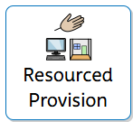
Our Resourced Provision Classrooms
At St Joseph’s we have two Resourced Provision room – The Orchard and The Woodlands. We work closely as team, supporting the children at their own individual level of need.

Who are the rooms for?
- The Orchard classroom is for some of our non-verbal learners. All children have a Special Educational and Health Care Plan (EHCP) or who are undergoing an Educational, Health and Care Assessment (EHCA). The Orchard classroom supports children from Year 1 to Year 6 and is aimed at children who have consistent difficulties with social communication and interaction and who also may have an Autism Spectrum Diagnosis. Children in here receive a bespoke sensory curriculum in a small group as well as individual Target Time to work on their EHCP targets.
- The Woodlands Classroom is for some of our learners who are working below the Expected Standard for their year or Key Stage. The children who access The Woodlands work in a more academic and class-like way that supports their learning. These children may also find the whole class environment challenging at times and may struggle to access their year groups curriculum due to academic barriers. The children are taught using the National Curriculum, with lessons adapted to meet their individual needs.
Our Aims:
- We aim to support pupils to make positive relationships with their peers.
- We aim to help children identify their own sensory triggers and challenges, guiding them to manage them through self-regulation.
- We have an emphasis on supporting children develop their awareness of others through increasing their social and communication skills through a provision-based approach to learning.
- We aim to provide all our children in the Resourced Provision rooms with experiences which promote greater independence and help children to develop important life skills.

